Elementary Guidance Lesson Plan

Counselor: Tiffany Schuette

Lesson: #2

Unit: Self-Esteem & Academic Success

Title: Get Into a Growth Mindset

Grade Level: Fourth & Fifth

Time: 30-45 Minutes

Learning Target:
I can understand the meaning of a fixed and growth mindset.

Materials:
- Mindset pre- and post- survey
- “The Girl Who Never Made Mistakes” by Mark Pett – Book
- Document camera for the book
- Computer for videos
- Lesson adapted from: http://theschoolcounselorkind.wordpress.com/tag/closed-mindset/

Learning Activities:
- Tell students that we are going to take a pre- and post- test to see how much you know now and how much you learned afterwards. Explain that it is not a test you get graded on, it’s a just so we can see how much you learned. Administer the mindset pre-test and read each item aloud with students and collect.
- Write the word mindset on the board and allow students to guess what it means. They may say: “when your mind is set on something” and “how your mind thinks about things.”
- Talk about fixed vs. growth mindset and write it on the board. Pair students up and give them a minute to discuss the difference. Elicit responses.
- Explain that when someone is in a fixed mindset they give up easily, they don’t try things that might be hard, and they don’t believe that they can learn. Give a few examples of what someone with a fixed mindset would say: “This math is too hard,” “I can’t do this,” “I’m not going to try,” “I can’t make any friends,” and “No one here helps me.” Ask them how well someone with that kind of mindset would learn; not very well at all!
- When someone has a growth mindset they don’t give up, they believe they can learn and that, in a sense, their brain can grow. Give a few examples of what someone with a growth mindset would say: “This math is hard, but I’m going to keep trying,” “I can do this,” and “I don’t have any friends….yet.” Students with this kind of mindset would learn much better. Discuss the power of yet - adding yet onto the end of a sentence can make all the difference!
- Growth Mindset video: https://www.youtube.com/watch?v=ElVUqv0v1EE
- Growth Mindset in a Pigsty video: https://www.youtube.com/watch?v=wNG41u3xbDc&index=6&list=PLpzLAWxRHSdA4iTpa5N2kxDaeGd5-25p9
- Post the Mindset Visual on the board and as a class go through the “What Can I Say to Myself?” chart.

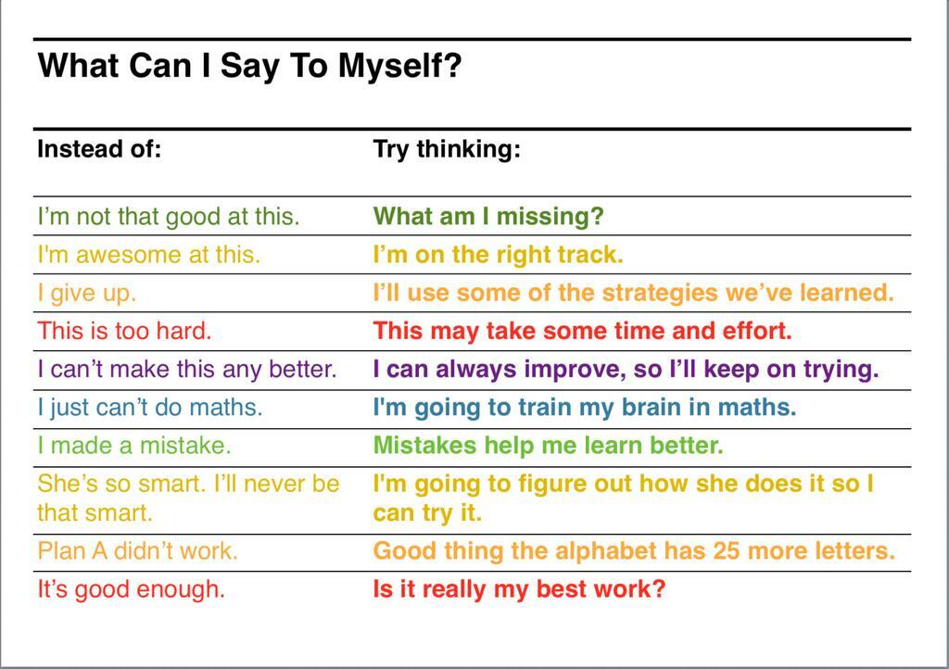
- Growth Mindset Animation video. https://www.youtube.com/watch?v=-_oqghnxBmY
- Mindset the new Psychology of success. Play only until 4:16 and end video https://www.youtube.com/watch?v=2eiJM5y6-9A
- Read “The Girl Who Never Made Mistakes” by Mark Pett to discuss how it is okay to make mistakes. We learn from those mistakes and we just persevere and keep moving forward.
- View the video ‘Keep Moving Forward’: https://www.youtube.com/watch?v=LmW3H-EXYS0
- Ornie the Pig in the growth mindset: https://www.youtube.com/watch?v=xd63g3d8qOs
- Sesame Street: Bruno Mars: Don’t Give Up: https://www.youtube.com/watch?v=pWp6kkz-pnQ&list=PLpzLAWxRHSdA4iTpa5N2kxDaeGd5-25p9&index=4
- In closure, ask students what a growth mindset is and elicit responses. Ask what a fixed mindset is and elicit responses. Ask: Can anyone learn even if something is hard? Administer the mindset post-test, read each item aloud with students and collect.

